Airline Utilization and Costs analysis

CA One – Business Intelligence and Visualisation

TANUJ GUPTA

10524198

Contents

Introduction 1

Datasets 1

Visualisation Objectives 1

Utilization 1

For each Airline carrier, to find trends that may give airline senior management an indication on their flight utilization. In order to achieve this, LOAD FACTOR metrics will be used. 1

Although, this is an important efficiency measure, but it does not consider the pricing and the profitability at which the capacity is sold. Hence the second objective. 1

Fuel Costs 1

Key Measures 2

Load Factor 2

Month over Month Change 2

Steps for Visualisation 2

Justifications for Visualisation Techniques 4

SLICERS 4

MULTI ROW CARD 4

BAR CHARTS 4

COLUMN CHARTS 4

ArcGIS MAP 4

Interpretations and Conclusion 4

Insights on Selected Airline – JetBlue Airways 4

Conclusion 4

# 

# Introduction

The airlines industry provides air transportation for passengers and cargo by using aircraft such as airplanes and helicopters. The industry is structured into three main components: commercial, general, and military. US Commercial aviation includes national carriers such as Delta and American etc, and regional carriers like GoJet and SkyWest Airlines and many more. According to the trade organization Airlines for America, commercial aviation helps drive more than $1.5 trillion per year in U.S. economic activity and more than 11 million U.S. jobs.

Air transportation may be scheduled or non-scheduled. Most commercial airlines operate according to a schedule, flying regular routes, even if the plane is not full. Air carriers that do not operate based on a schedule usually fly during off-peak hours, and usually have more flexibility regarding choice of airport, flight times, and load factors.

In this report and visualisation, we will be gaining insights on the Airline Industry with datasets downloaded from the US Department of Transportation. We will analyse data from the year 2019, for airlines domestically, to look for trends in utilization and fuel costs.

# Datasets

All the datasets used in the visualisation are downloaded from the US Department of Transportation.

Dataset 1 – Airlines and their monthly fuel costs and fuel consumptions.

Dataset 2 - Airlines and their monthly flights details including Origin Airport, Destination Airport, Seats Available per flight, Passengers, Distance between the origin and destination airports

Dataset 3 – Aircrafts Model and Aircrafts Name.

# Visualisation Objectives

## Utilization

## For each Airline carrier, to find trends that may give airline senior management an indication on their flight utilization. In order to achieve this, LOAD FACTOR metrics will be used.

## Although, this is an important efficiency measure, but it does not consider the pricing and the profitability at which the capacity is sold. Hence the second objective.

## Fuel Costs

Objective is to look at the monthly expenditure in terms of fuel on flights. Combining costs and utilization, management would gain the complete insights.

# Key Measures

## Load Factor

Load Factor (LF), also known as passenger load factor (PLF), is an airline industry metric that measures how much of an airline’s passenger carrying capacity is used. PLF is one of the most critical metrics from a capacity management perspective. Airlines not only try to maximize their PLF, but also take decisions about pricing, capacity and frequency of flights based on this key performance indicator.

## Month over Month Change

Month-on-previous-month change rates are rates of change expressed with respect to the previous month. For Airlines, we will be looking at fuel costs change.

# Steps for Visualisation

1. **Connecting to Data Source**
   1. 3 Excel files loaded
2. **Shape and Transform**
   1. Filtered WorkSheets and Removed Unwanted columns, Renamed columns and datasets
   2. Defined Data Types – Cities as Places, Costs as Decimal with currency as US Dollars.
3. **Created Calculated Columns**
   1. **Revenue Passenger Miles = Passengers * Distance**
   2. **Available Seat Miles = Seats * Distance**
   3. **Date =**

**var year = "2019"**

**var selected_month_name = 'Airline Fuel Costs'[Short Month]**

**var month_as_date = DATEVALUE(selected_month_name & " " & year)**

**return month_as_date**

1. **Loaded into Power BI Data Model**
2. **Created New Tables to avoid Many-to-many relationships**
   1. **Airline Name – Unique Carrier Names**
   2. **Date – Date Table (using calendar function)**
   3. **Month – Numeric Month Distinct Values**
3. **Created Relationships between datasets (avoiding all many-to-many)**

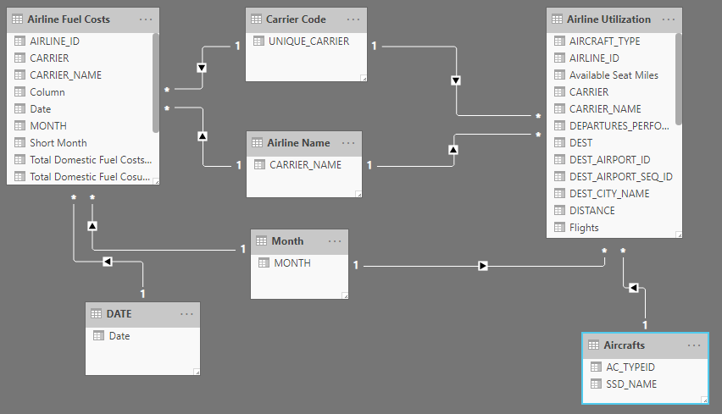

1. **Created Calculated Columns (post load)**

**Flights = CONCATENATE('Airline Utilization'[ORIGIN],CONCATENATE(" to ",'Airline Utilization'[DEST]))**

1. **Created Measures** 
   1. **LOAD FACTOR % = SUM('Airline Utilization'[Revenue Passenger Miles])/SUM('Airline Utilization'[Available Seat Miles])**
   2. **Previous Month Fuel Costs = CALCULATE(SUM('Airline Fuel Costs'[Total Domestic Fuel Costs (USD)]),DATEADD('DATE'[Date], -1, MONTH))**
   3. **Month Over Month Change =**

**IF('Airline Fuel Costs'[Previous Month Fuel Costs] <> 0,(SELECTEDVALUE('Airline Fuel Costs'[Total Domestic Fuel Costs (USD)])-'Airline Fuel Costs'[Previous Month Fuel Costs]) /'Airline Fuel Costs'[Previous Month Fuel Costs], BLANK())**

1. **Created Dashboard with –**
   1. **Two Slicers – To select frequency of flights and to select Origin City/Airport**
   2. **ArcGIS Map to Map all the destinations, load factor.**
   3. **Two Stacked Bar Charts**
   4. **Two Column Charts**
   5. **A Multi-row Card.**

# Justifications for Visualisation Techniques

## SLICERS

To give the dashboard a dynamic selection panel. Since the number of flights varies from airlines to airlines, one could select a frequency and only the resultant airlines would be shown, or for a selected airline, only the airports within the flight frequency range would be available. Similarly, for the Origin Airport, a dynamic filter would focus the utilization report on the airline and specific city.

## MULTI ROW CARD

Multi-row card is perfect to summarize all the KPIs and metrices. One look at the dashboard, the summary results are available to the user.

BAR CHARTS

In the bar chart on the left I can analyse load factor by originating airport. Or, if I choose, I can look at the number of flights arriving at different destinations. Since this information needs to be conveyed and not compared, bar charts are perfect for use.

## COLUMN CHARTS

Since the numbers needs to be compared, column charts are perfect technique to use for LOAD Factor comparison by Aircraft Model and Month-Over-Month Fuel Costs change.

## ArcGIS MAP

Similar to Power BI built-in Map, ArcGIS provides more dynamicity to the dashboard. Used to get the different base map and One-Country focused approach in this dashboard.

# Interpretations and Conclusion

## Insights on Selected Airline – JetBlue Airways

From a JetBlue Airways senior management perspective, from the dashboard I can say –

1. Going from Month May to June, the airline saved 9.93% in fuel costs and lost 18.1% from month Feb-March. Meaning the airline should try to cut costs in the first quarter of the year.
2. In terms of capacity management, the least utilized flights originate from Yampa Valley, Colorado (HDN Airport). With overall load factor of 61.4%, the management should try to reduce some flights from this airport as for three destinations, currently JetBlue is offering 6 flights.
3. The most utilized Aircraft for JetBlue is the A321 Model with 87.27% load factor.
4. Furthermore, Utilization for the airline can be drilled down to specific months (can be filtered on the page).

## Conclusion

The airlines have a vested interest in providing the best possible service to passengers. The largest airlines are, as they have always been, competing with each other every day. Couple that with the emergence and popularity of smaller, primarily low-cost carriers and ultra-low-cost carriers and it is plain to see there is no shortage of competition. So in order to remain ahead in the competition, Airlines needs to have highly utilized options in terms capacity as well as costs. This dashboard would be really useful to get just those insights.